**Wall.**

This is the defensive structure around your base that can help defend you against oncoming attacks.

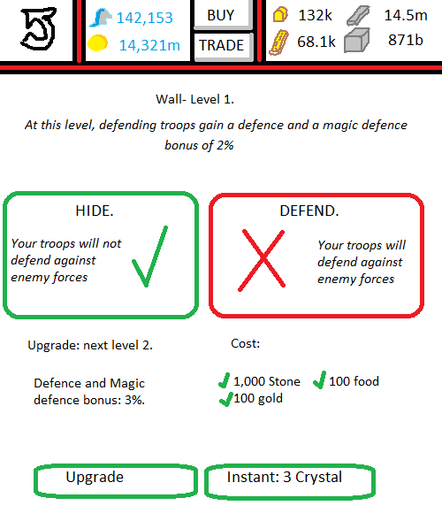

**User Interface: Main Base.**Selecting the wall opens a mini-menu. 2 options are given:  
 1. Go to wall.  
 2. Switch from HIDE-DEFEND.

**User Interface: Wall.**Clicking either HIDE or DEFEND will ask if you want to switch to that mode. Whichever is currently selected, will be green with a giant tick. Whichever is not active will be red with a giant cross.  
‘Upgrade’ will be ghosted if you do not have the correct resources. If you do, and you click it, your building will go into the building queue.   
‘Instant: 3 crystal’ will instantly upgrade your wall to level 2, without a build queue, and will deduct 3 crystal from your balance.

**Graphics in use:**GIMB_038. (1) Wall. Graphic of wall from wall level 1 to 4.  
GIMB_039. (2) Wall. Graphic of wall from wall level 5 to 9.  
GIMB_040. (3) Wall. Graphic of wall from levels 10+.  
GIA_012. Green Tick.  
GIA_013. Red Cross.

**Variables in use:**VS_WL1. The variable value corresponds to the level of your wall in your main base.  
VS_WL2. The variable value corresponds to the level of your wall in your 2nd city.  
VS_WL3- VS_WL6. The variable corresponds to the level of your wall in your 3rd to 6th cities.  
VT_W1 to VT_W6. Trigger variable. A value of 0 means troops are on HIDE, a value of 1 means troops are on DEFEND.